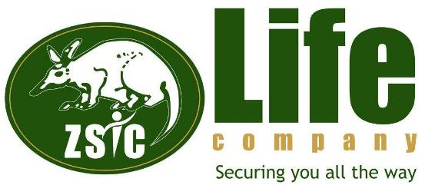

EMPLOYMENT OPPORTUNITY

SYSTEMS DEVELOPER – MOBILE APPLICATIONS

ZSIC Life Plc is a leading long-term life assurance Company wholly owned by the Industrial Development Corporation (IDC). The Company has a well spread branch network across Zambia, providing the market with flexible, reliable, and quality life assurance, pension and fund management services through innovation and a motivated workforce. In order to live up to this mandate and realise its vision of being the “Most preferred provider of exceptional insurance and pension services”, the company invites applications from suitably qualified, result oriented and self-motivated Zambian nationals to fill the position of Systems Developer -Mobile Applications, under the Information Technology Department, to be based at the Headquarters in Lusaka.

Job Purpose
To develop, maintain, and design mobile applications for various platforms, such as iOS and Android. Working with project managers and stakeholders, the job holder designs and develops mobile applications that appropriately meet project requirements. The job also entails making mobile applications efficient, responsive, and easy to use.

Responsibilities | Technical Proficiency
- Design and build advanced applications for the Android/ iOS platform  - Collaborate with cross-functional teams to define, design, and finalise new features  - Ensure the performance, quality, and responsiveness of applications  - Work with outside data sources and APIs  - Unit-test code for robustness, including edge cases, usability, and general reliability  - Work on bug fixing and improving application performance  - Continuously discover, evaluate, and implement new technologies to maximize development efficiency  - Coordinate with various teams to ensure all development tasks meet quality criteria.  - Work closely on the deadlines of the project  - Keep raising the bar and standards of all the quality processes with every project | - Proven software development experience and Android/iOS skills development  - Proven working experience in Android/iOS app development and have published at least -05- original Android/iOS app  - Experience with third-party libraries and APIs  - Vast knowledge of the general mobile landscape, architectures, trends, and emerging technologies  - Solid understanding of the full mobile development life cycle  - Experience in Mobile Application design, development & deployment  - Deep experience in hybrid mobile app development for iOS and Android platforms using HTML5, CSS3, Javascript, JQuery mobile, XCode, Appcelerator/Titanium  - Alloy framework, Eclipse, iOS SDK and Android SDK  - Should have hands-on experience in all stages of Mobile app life cycle - concept, design, build, deploy, test, release to app stores and support.  - Experience in implementing Web Applications and Web Services in .NET/Java technologies is a plus  - Experience on web service integration (SOAP, REST, JSON, XML)  - Experience with at least one of the latest JavaScript frameworks like Xamarin, Angular JS, React JS, Ionic 2/3 and Cordova  - Excellent understanding of Mobile computing Techniques for Android/Ios/USSD
Qualifications | Attributes
- Full Zambian School Certificate or its equivalent.  - University degree in computer sciences or equivalent  - Minimum of two years technical work experience | - Self -motivated  - Creativity  - Supportive  - Integrity  - Team player  - Goal Oriented
Skills | Terms of Appointment
- Excellent verbal and written communication skills  - Project management  - Negotiating skills  - Leadership and motivation skills  - High level of computer literacy  - Monitoring and Evaluation Skills | Two years fixed term contract renewable depending on satisfactory performance
APPLICATION PROCEDURE
Interested persons can send their application letters accompanied by Curriculum Vitae and certified copies of academic qualifications to jobs@zsiclife.co.zm by close of business on 29th September 2023.
Letters should be addressed to:
The Head Human Capital & Administration
ZSIC Life Plc,
Insurance House,
Stand No. 4432 Cairo Road,
Box 30507,
LUSAKA.

ONLY SHORTLISTED APPLICANTS WILL BE COMMUNICATED TO

